**Azure Function**

**Its is Paas Platform as a service , its is serverless because we don’t need to** bother about infrastructure , application scaling . Everythings

Are handled automatically . It is written in such a way that it consume less amount of source and time efficient transactions.

In AZ Queue section we were consuming message using background service , but will use AZ function which will be more scalable can be deployed on other environment.

1. We will create AZ function in VS
2. Select Queue trigger for this case
3. 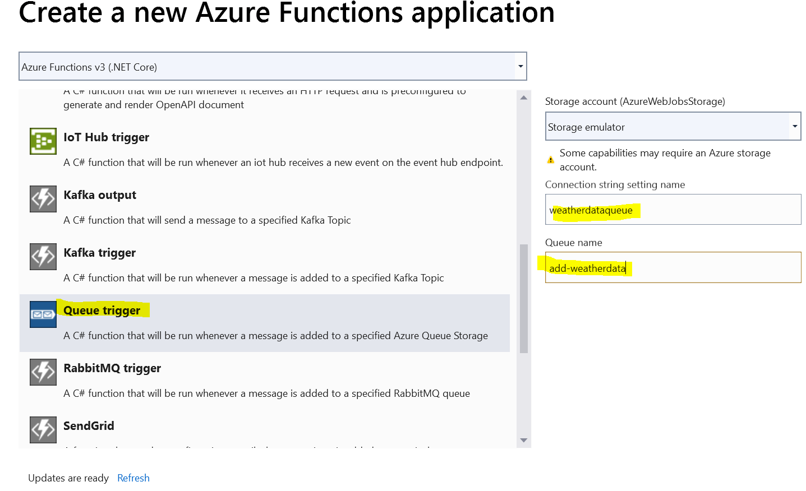
4. 
5. 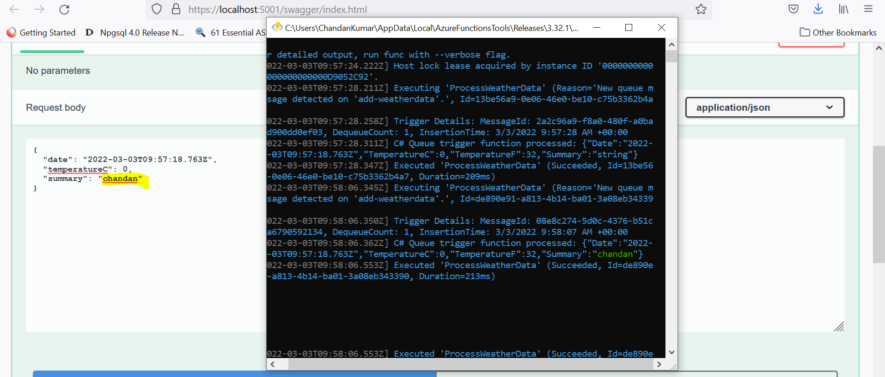
6. In case of Queue Storage and background process , we have explicitly write code to delete message from Queue , but in case of QueueTrigger , it automatically happen behind the scene

Only if function return successfully , if something goes wrong in function then that message will not be delete from queue